## **Build an LED Binary counter:**

## 

## **Introduction**

To understand this project, you need a working knowledge of binary numbers.

We will be using the LEDs to indicate a 1 (on) or 0 (off) for the first 4 place values in the binary place value table. That means we can represent numbers from 0 to 15.

## **You Will Need**

* 4 x LEDs
* 4 x 330 Ohm Resistors
* Jumper Wires

## **Making The Circuit**

The diagram shows how the circuit should look.

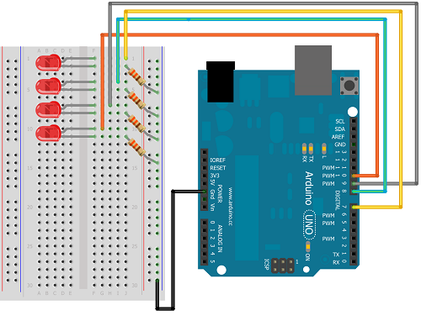

If you have been working through the projects in order, this is the circuit with the most wiring. With a bit of concentration, this one shouldn't be too much of a problem. Make sure that the longer lead (positive) of each LED is the one you connect to the Arduino pin and that the resistors connect the shorter lead (negative) to the GND rail.

To relate this to the binary place value table, turn the breadboard 90° in a clockwise direction. The LED at the top of the breadboard (connected to pin 7) becomes the rightmost bit (units). When this LED is on, that will mean a 1 in the units column. Moving leftwards, we have 2, 4 & 8 for our column headings.

**Arduino code:**

void **setup**()

{

pinMode(2, OUTPUT);

pinMode(3, OUTPUT);

pinMode(4, OUTPUT);

pinMode(5, OUTPUT);

}

void **loop**()

{

digitalWrite(2,0);*//0000*

digitalWrite(3,0);

digitalWrite(4,0);

digitalWrite(5,0);

delay(1000);

digitalWrite(2,1);*//0001*

digitalWrite(3,0);

digitalWrite(4,0);

digitalWrite(5,0);

delay(1000);

digitalWrite(2,0);*//0010*

digitalWrite(3,1);

digitalWrite(4,0);

digitalWrite(5,0);

delay(1000);

digitalWrite(2,1);*//0011*

digitalWrite(3,1);

digitalWrite(4,0);

digitalWrite(5,0);

delay(1000);

digitalWrite(2,0);*//0100*

digitalWrite(3,0);

digitalWrite(4,1);

digitalWrite(5,0);

delay(1000);

digitalWrite(2,1);*//0101*

digitalWrite(3,0);

digitalWrite(4,1);

digitalWrite(5,0);

delay(1000);

digitalWrite(2,0);*//0110*

digitalWrite(3,1);

digitalWrite(4,1);

digitalWrite(5,0);

delay(1000);

digitalWrite(2,1);*//0111*

digitalWrite(3,1);

digitalWrite(4,1);

digitalWrite(5,0);

delay(1000);

digitalWrite(2,0);*//1000*

digitalWrite(3,0);

digitalWrite(4,0);

digitalWrite(5,1);

delay(1000);

digitalWrite(2,1);*//1001*

digitalWrite(3,0);

digitalWrite(4,0);

digitalWrite(5,1);

delay(1000);

digitalWrite(2,0);*//1010*

digitalWrite(3,1);

digitalWrite(4,0);

digitalWrite(5,1);

delay(1000);

digitalWrite(2,1);*//1011*

digitalWrite(3,1);

digitalWrite(4,0);

digitalWrite(5,1);

delay(1000);

digitalWrite(2,0);*//1100*

digitalWrite(3,0);

digitalWrite(4,1);

digitalWrite(5,1);

delay(1000);

digitalWrite(2,1);*//1101*

digitalWrite(3,0);

digitalWrite(4,1);

digitalWrite(5,1);

delay(1000);

digitalWrite(2,0);*//1110*

digitalWrite(3,1);

digitalWrite(4,1);

digitalWrite(5,1);

delay(1000);

digitalWrite(2,1);*//1111*

digitalWrite(3,1);

digitalWrite(4,1);

digitalWrite(5,1);

delay(1000);

}

**Result of code will be:**

